TalkBox Simulator User Manual

Before using the simulator, the user MUST use the Talkbox Configurator and set up a button configuration. After creating their custom configuration and setting it in a directory, the user can now use the Talkbox Simulator.
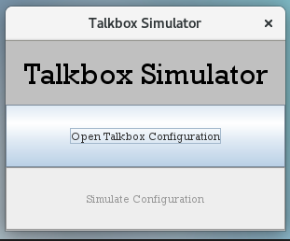

This is what the simulator looks like when just opened

In this simulator menu, the user can see two buttons.
- The Open Talkbox Configuration button: This button allows the user to open their existing configuration. It will open to a window that list all directories. The user selects the directory that they saved te configuration in, then the Simulate Configuration button will light up and will be ready to use.
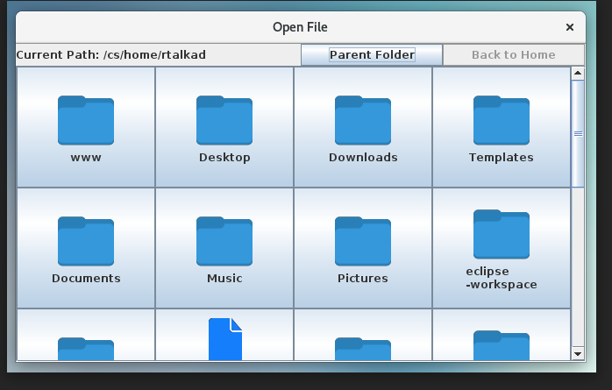

When the user selects “OK” a list of directories is shown
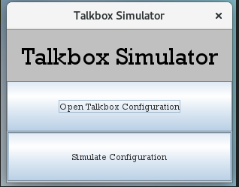

When directory is selected, the “Simulate Configuration” button will light up

- The Simulate Configuration button: This button will launch the rows of buttons that were saved and put in the directory chosen. This is where the user presses the buttons for the audio to be played.
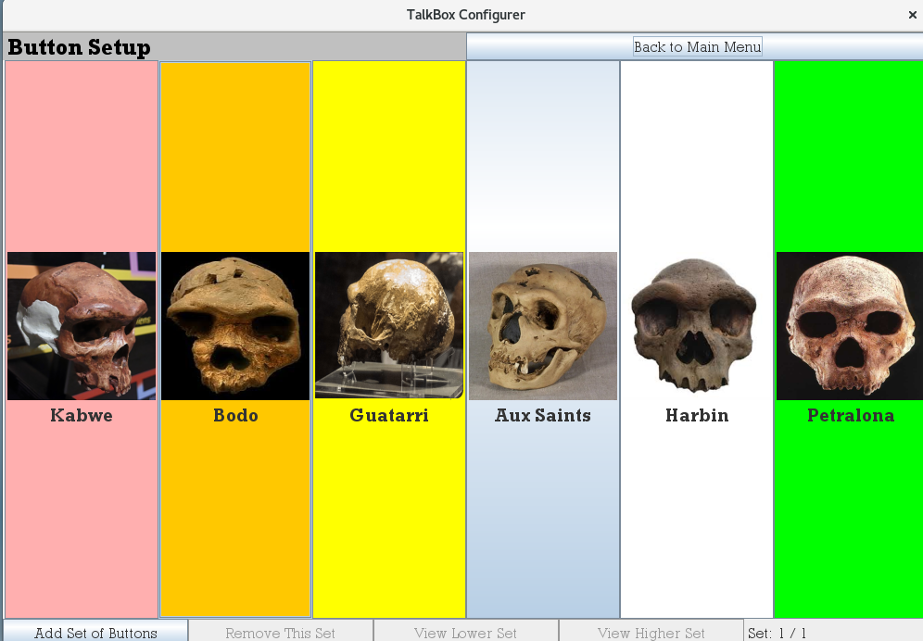

Previously saved setup will be shown

